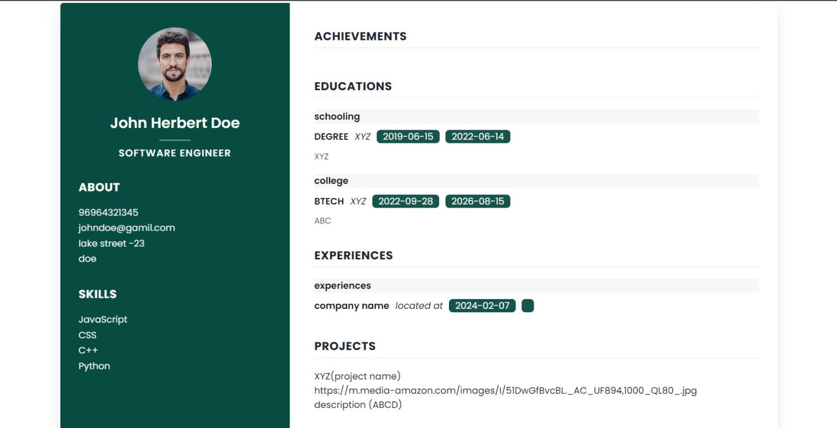

Figure.4.3.3. Real-Time previewing

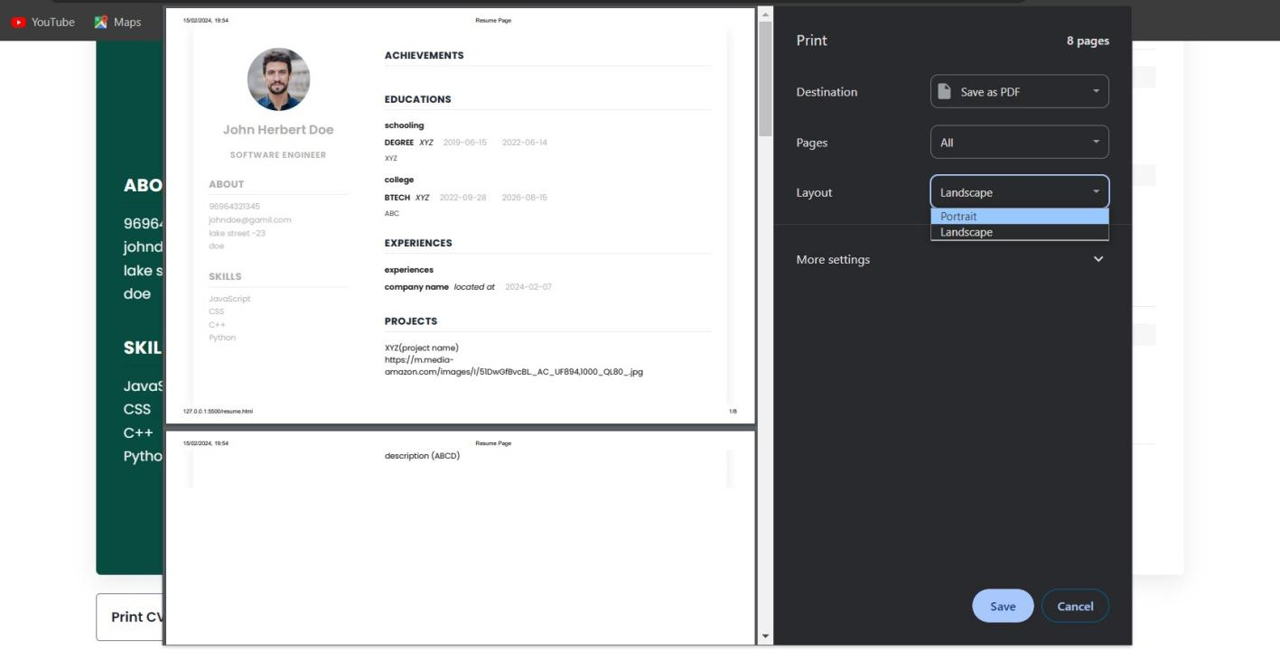

Figure.4.3.4. Format,color and layout selection